Water Level Observation (Kurogo Water-Level Gauging Station)

Shimodate River Work Office, MLIT

River water levels fluctuate, depending on changes in discharge and river-bed morphology. Kurogo Water-Level Gauging Station monitors the river water level at 10-minute intervals for 24 hours for the purpose of river management.

Kurogo Station uses two types of water-level gauges: float and ultrasonic types.

Observed data are used to produce a stage-discharge curve (H-Q curve), by which a river discharge can be estimated based on a water level.

Sample H-Q curve

H-Q curves are useful in river management, particularly in the case of flooding and drought, for a river discharge can be easily estimated from a water level. H-Q curves provide important information for flood forecasting and flood fighting during flooding and for intake water level and amount during drought.



observation hut

water level gauge

observation well

water conveyance pipe

**Float-type gauge:** This type of water-level gauges records water levels by transferring the movement of the float on the river surface to that of the recording pen through the wire and pulley.

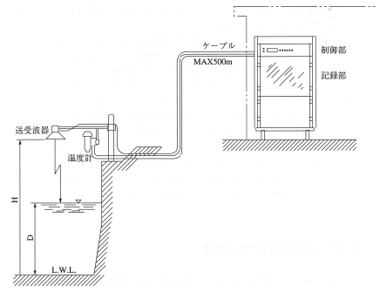

controller

cable

recorder

transducer

temperature sensor

**Ultrasonic-type gauge:** This type of gauges measures water levels by using ultrasonic transducers installed right above the river surface. They send ultrasonic waves to the river surface and receive the echo from it to determine the distance to the surface based on the traveling time of the waves. This way, they can measure water levels with no direct contact with the water surface.